**Acknowledgement**

We wish to express our gratitude to all the people involved in contributing this project of our website “BrokersBunch”. We take this opportunity to thank all who have helped us during the project work.

We would like to thank our college, St. Xavier’s College (Autonomous) for providing us the opportunity to work on project and gain experience from the same. We present our heartful thanks to the Vice Principal, **Dr. (Fr.) Johnson Mundupuzhakal** for sharing his generous time and knowledge with us which helped us to complete this project on time and present it to the examiners.

Genuine thanks to **Ms. Nithya Nadar**, our internal guide for her critical reviews of the project which help us to make this more presentable. Her gentle support and direction guided us in all aspects of the project. It has been pleasure to work with **“Hauper Technologies Pvt. Ltd.”**, and we appreciate the cooperation of the staff. Our special thanks to the external guide **Mr. Abhishek Shah** for his kind review of the project.

We would also like to thank all the faculty members of St. Xavier’s College (Autonomous) for their tangible, but always unspoken support for this project.

Last but not the least we would like to express our sincere thanks to our parents for their precious support and their motivation for completing this project.

**INDEX**

**INDEX**

**Sr. No. TOPIC PAGE NO.**

1. INTRODUCTION………………………………………………………………......1
2. ORGANIZATION PROFILE……………………………………………………….2
3. PROJECT PROFILE………………………………………………………………..4

3.1 EXISTING SYSTEM………………………………………...................5

3.2 PROPOSED SYSTEM………………………………………………….6

3.3 DEVELOPMENT TOOLS AND TECHNOLOGY USED……………..8

1. DATA FLOW DIAGRAM….…………….………………………………………...9
2. ENTITY RELATIONSHIP DIAGRAM..………………………………………….19
3. DATA DICTIONARY……………………………………………………………...21
4. BIBLIOGRAPHY…………………………………………………………………..31

**Introduction**

**Introduction**

Our documentation for the project “BrokersBunch” involves certain details and information about the company that provided us with the project definition. This is followed by a short briefing of the requirements and analysis of our project, the existing system and our proposed system.

We have documented the DFDs made during the analysis phase, starting with the context level which shows the System and their corresponding entities like ADMIN, CLIENT, and BROKER then the first level diagram showing the various activities of the ADMIN, CLIENT and BROKER, the second diagram showing the elaborate explanation and functioning of each processes of the first level.

The documentation further contains the Data Dictionary which will be used for making a database during the development and coding stage.

Lastly, we have made ERD to show the relationships between the tables.

**Organisation Profile**

**Organisation Profile**

* Company Name :- Hauper Technologies.
* Company Logo :-



* Company address :- 501, Shivalik Shilp, Near Iscon Circle, S.G highway, Ahmedabad.
* Contact number:- +919978707853
* **About Company**
* Hauper technologies is a web design and development company established and located in India. It was founded to address the core problem in the IT industry of lack of passion about creating products.
* They are always in quest of finding people with whom they can build a product that has utility.
* The company is always ready to provide its Customers with original design idea, robust and scalable applications, dedicated technical assistance and support.

**Project Profile**

**About Project**

This web application provides a common platform for broker and client to sale or buy property.

The client can search for property. If found some reliable property s/he can set appointment with the broker for visiting property. If interested in buying/selling they can send or recieve messages .

Client need to pay brokerage commission through platform if wants to buy property.

**Requirement Gathering**

We referred to some of existing system they work for both broker and owner of property . In order to that we talked with some of the people as well as broker around us and thought of creating a platform for broker’s community. This web application will reduce the work of brokers and help them grow their business. Broker can list the property details.

Client can search for the required property easily using several filters. Client can book appointment for the properties in which they are interested. If they have further queries, they can solve it through messaging.

**Existing System**

Currently broker and owner needs to register their property on the website, so both the parties share same platform. So buyer will mostly go for the property which is registered by the owner as it has no brokerage commission. There is limited scope for the development of broker’s business.

There is no option for appointment to visit the property.

**Proposed System Entities (Actors)**

* Admin
* Broker
* Client
* **ADMIN**
* **Register :-** The Admin will register his account by entering the username, email address and password.
* **Login :-** The Admin will login into his account by entering the username and password.
* **Managing database :-** The Admin will verify and delete or add broker details. Admin will check the status of the properties and perform the required action. Admin will manage the feedbacks provided by the broker and add some of them to testimonials section on homepage. Admin can view payment details.
* **BROKER**
* **Login/Register** :- Broker will login/register on website with user id and password. They can login using other platform such as google, Facebook etc. They can also login using their email id and password. Listing the property:
* **Listing the property :-** Broker will collect all the details provided by his client in order to sell a property. Broker will upload details of the property such as:
  + - Images of property
    - Type of property
    - Number of floors
    - Dimensions
    - Location
    - Selling Price of the Property
* **Fixing Appointment :-** Broker will receive appointment request from client. If interested he can accept the request. If interested but not able to go on the time given by broker then s/he can reschedule appointment. If not interested then can delete the appointment request.
* **Messaging :-** Broker can send or receive messages for the deal, if client have some queries
* **Payments :-** Broker will receive his commission through the platform.
* **CLIENT**
  + **Login/register :-** Client will login/register on website with user id and password. They can login using other platform such as google, facebook etc. They can also login using their email id and password.
  + **Searching property :-** Client will search for property . Client can apply the filters according their requirement.
  + **Fixing Appointment :-**  If client finds appropriate property then they can schedule appointment. If broker accepts the appointment they can visit the property.
  + **Messaging :-** If Client has any queries, then they can solve it through messages.
  + **Payments :-** If client interested in any property, then they need to pay the brokerage commission through platform.

**DEVELOPMENT TOOLS AND TECHNOLOGY USED**

* **Front End :-**
  + - * PHP
      * Javascript CSS
      * HTML
      * Jquery
* **Back End** **:-**
  + - * MySQL
* **Server:-**
  + - * XAMPP
* **Other Tools** **:-**
  + - * MS Office 2016

* + - * draw.io

**Data Flow Diagram**

**Level - 0**

**Level - 1**

**Level**

**Level - 2**

**2.0 Login**

**3.0 Broker**

**Level**

**4.0 Property**

**5.0 Appointment**

**Entity Relationship Diagram**

**Data Dictionary**

**DATA DICTIONARY**

1. USER_TBL
2. BROKER_TBL
3. PROPERTY_TBL
4. IMAGE_DETAILS_TBL
5. IMAGE_TBL
6. PROPERTY_TYPE_TBL
7. FLAT_TBL
8. PLOT_TBL
9. STATE_TBL
10. CITY_TBL
11. AREA_TBL
12. APPOINTMENT_TBL
13. MESSAGE_TBL
14. PAYMENT_TBL
15. FEEDBACK_TBL
16. PROPERTY_RELATION_TBL
17. 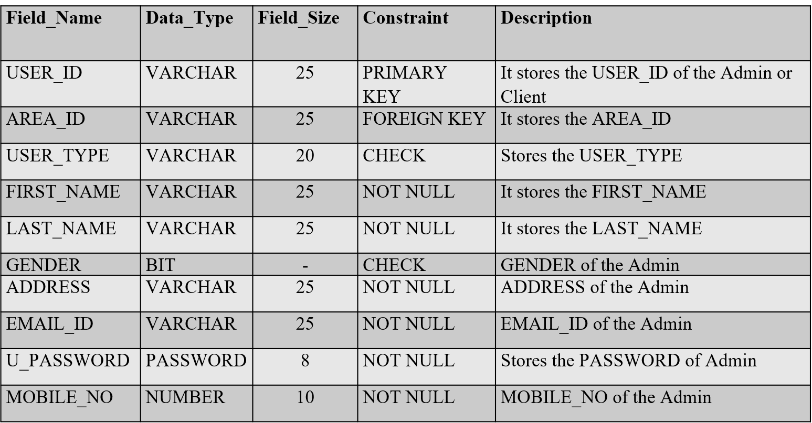**USER_TBL :- It stores the details of user on the basis of their type, Admin or Client.**
18. 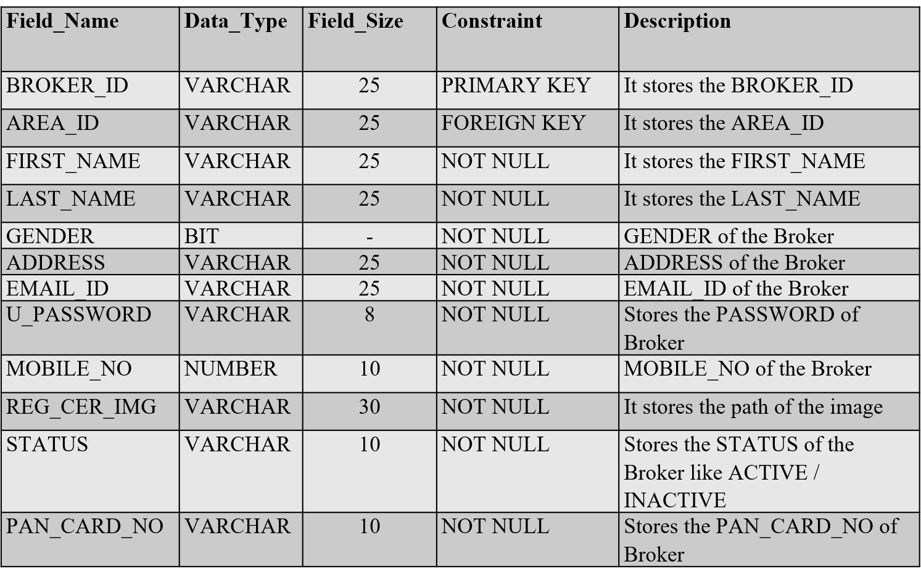**BROKER_TBL :- It stores the details of broker.**
19. 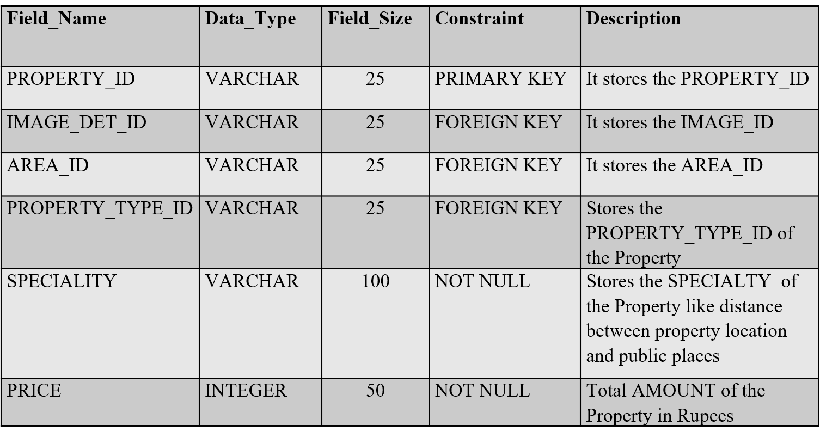**PROPERTY_TBL :- It stores the details of property.**
20. 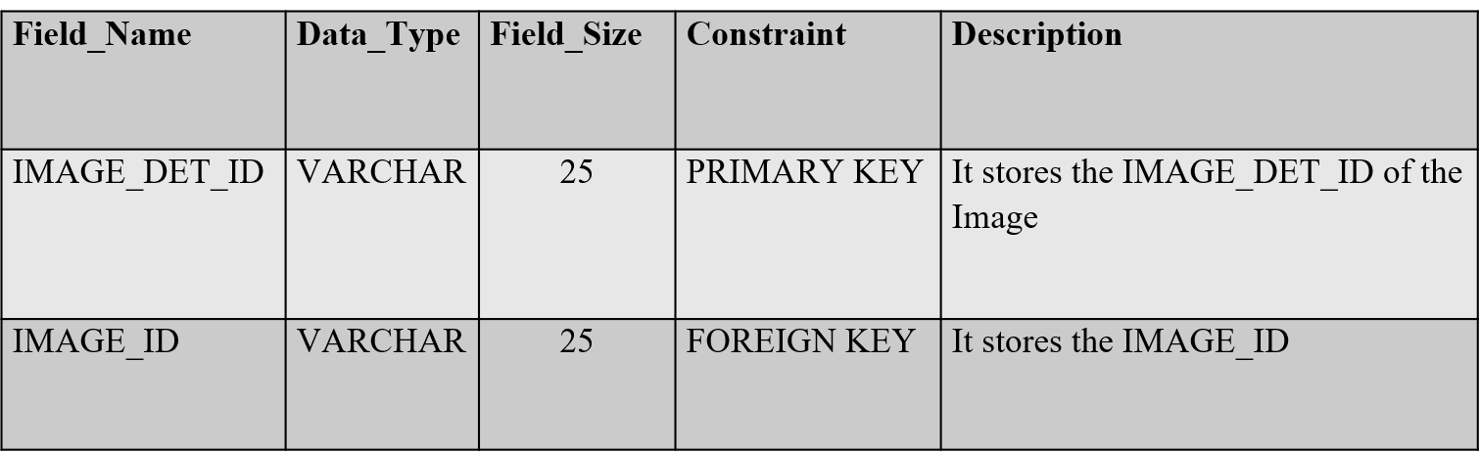**IMAGE_DETAILS_TBL :- It stores the id of images in order to retrieve them according to property.**
21. 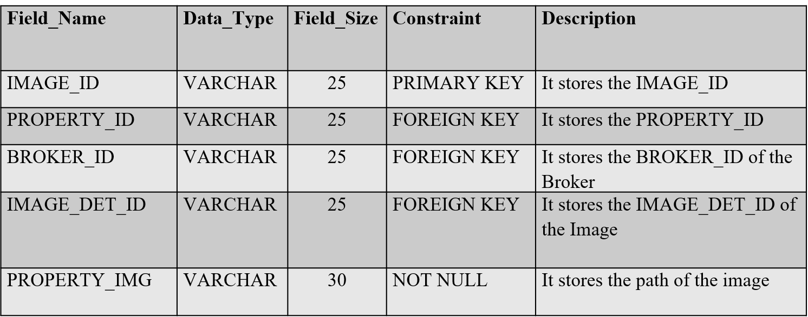**IMAGE _TBL :- It stores the number of images of the property.**
22. **PROPERTY_TYPE_TBL :- it stores the id of type of property.**

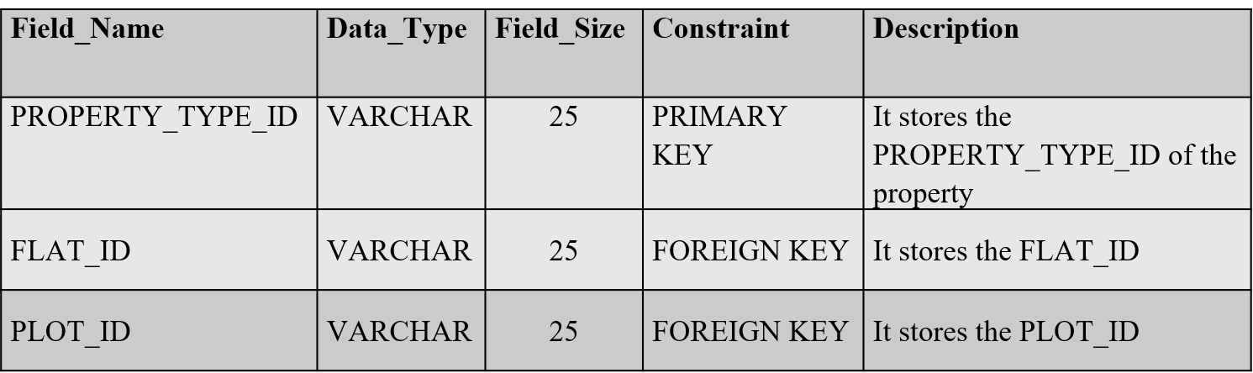

1. 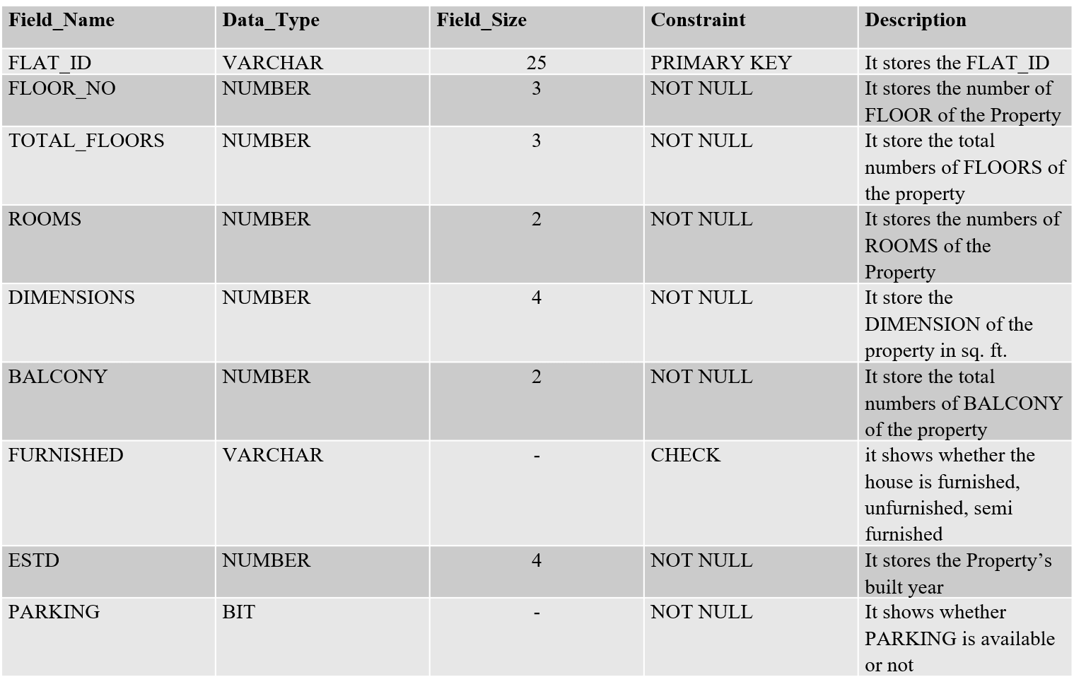**FLAT_TBL :- It stores the details of flat type of property.**
2. 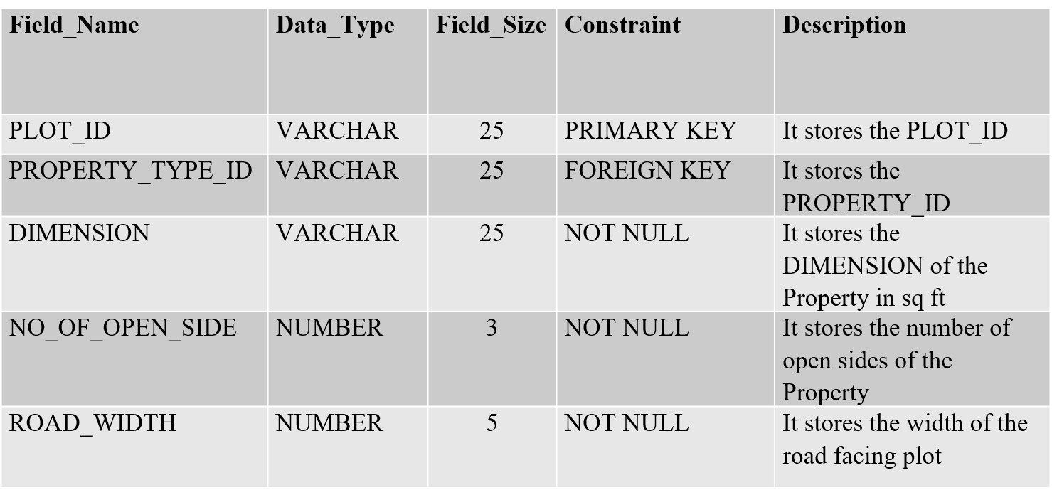**PLOT_TBL :- It stores the details of plot type of property.**
3. 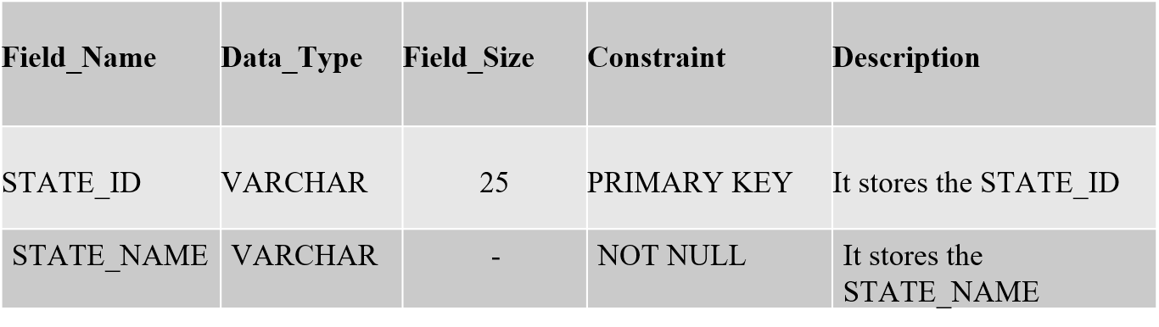**STATE_TBL :- It stores the State of property.**
4.** 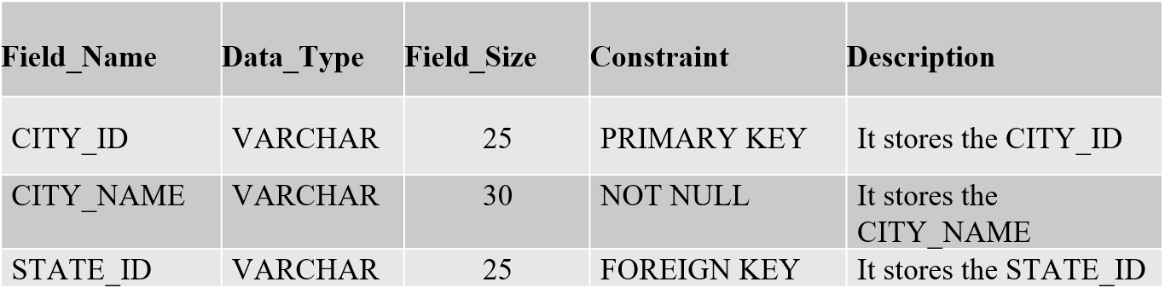) CITY_TBL :- It stores the city of property.**

**(11 ) AREA_TBL :- It stores the area of property.**

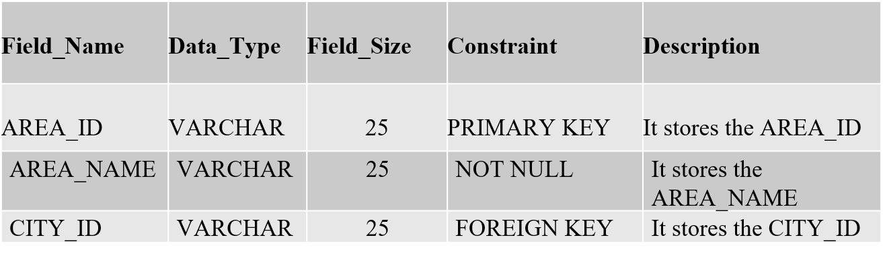

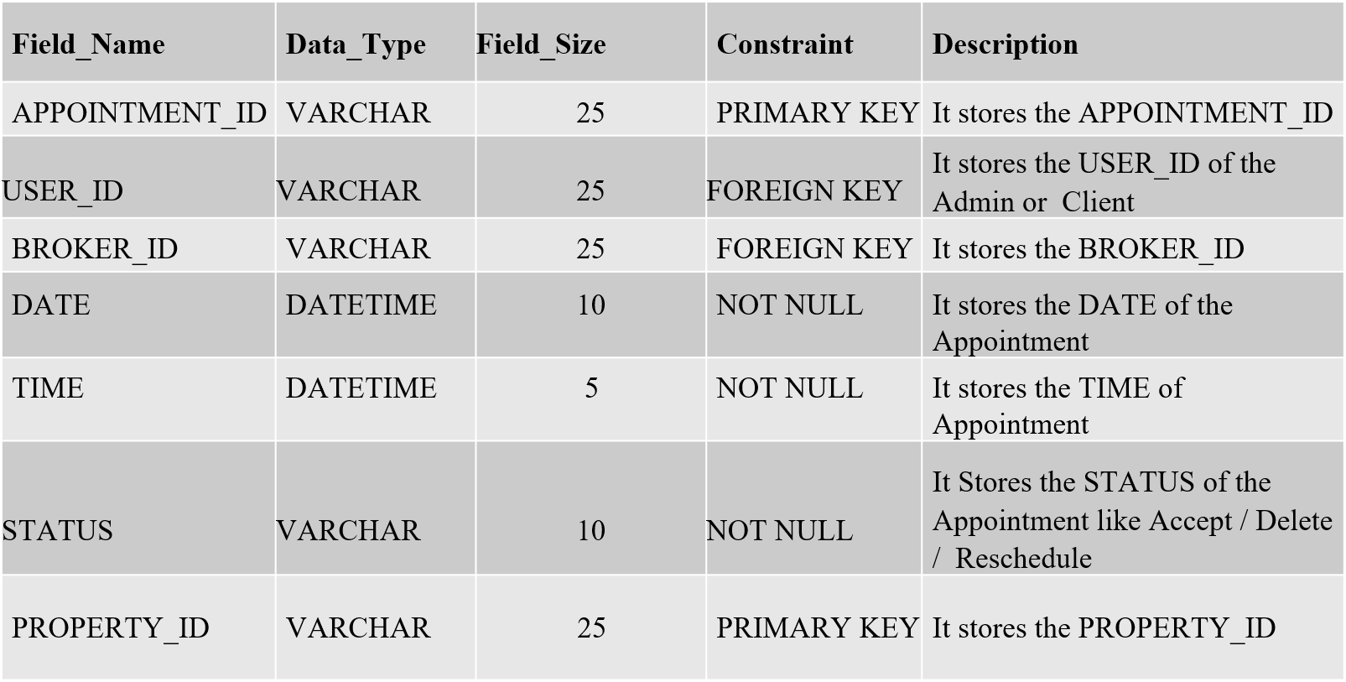**(12 ) APPOINTMENT_TBL : It stores the details of Appointment of property**

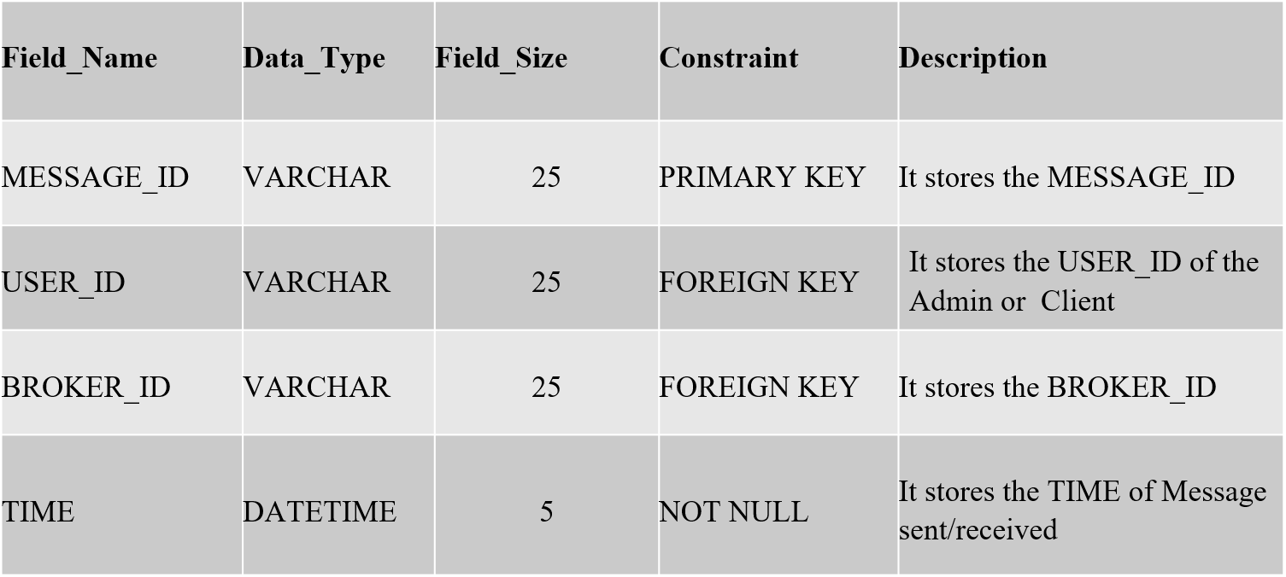**(13 ) MESSAGE_TBL: it stores the details of messages between broker and client.**

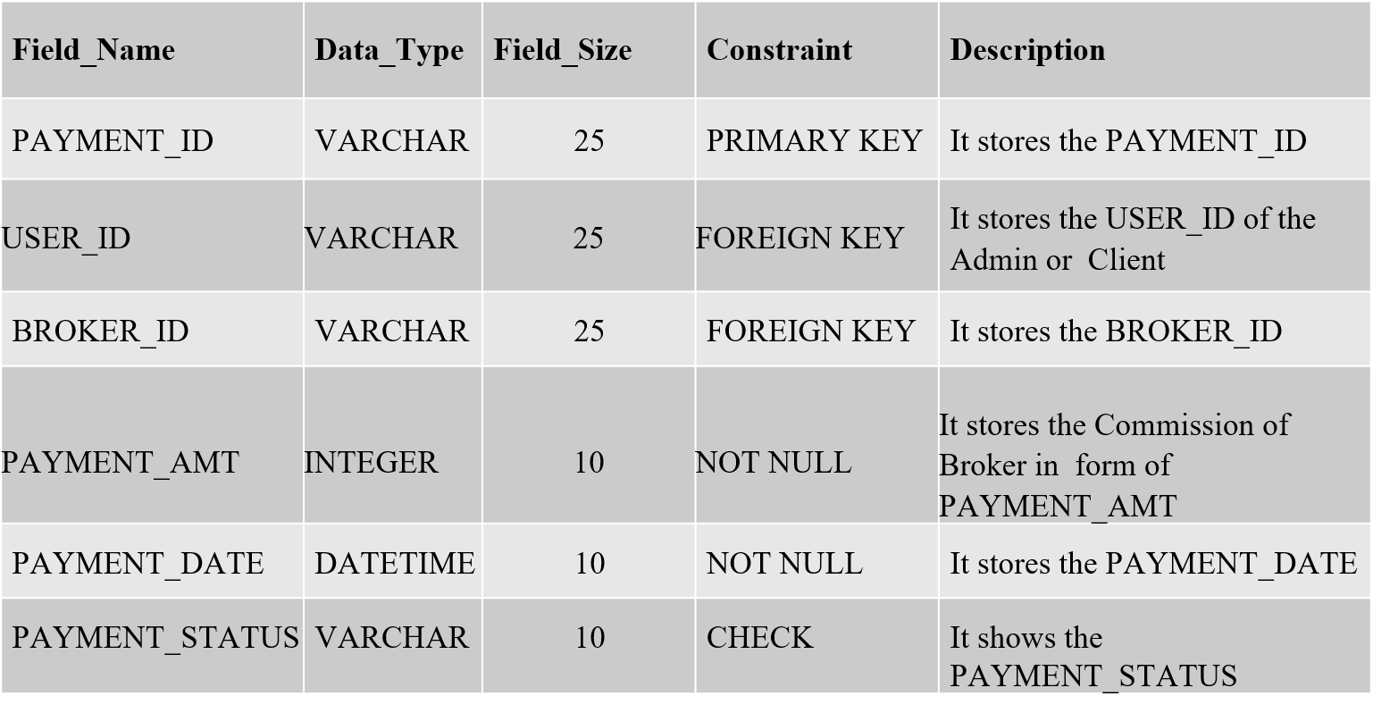**(14)** **PAYMENT_TBL : it stores the payment details of broker’s commission**

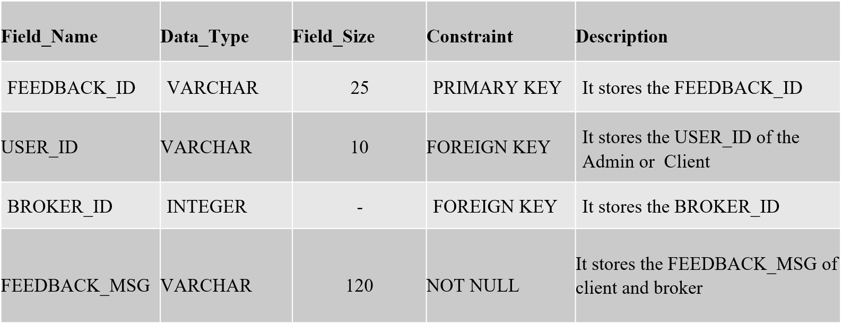**(15) FEEDBACK_TBL : It stores the feedback details .**

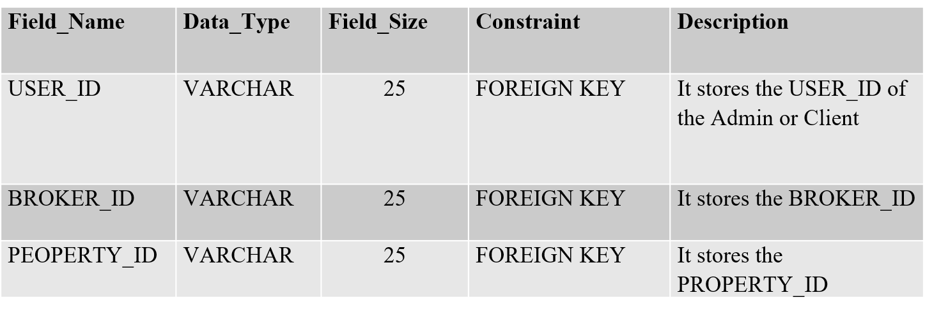**(16) PROP_RELATION_TBL : It stores the IDs of User, Broker, Property**

**Bibliography**

**Book references :-**

Magnifying Object-Oriented Analysis & Design

Publisher: PHI Learning Publication

Author: Arpita Gopal & Netra Patil

**Website references :-**

Tutorialspoint : www.tutorialspoint.co